University of Gujrat

Department of Software Engineering

Emerging Trends in Information and Communication Technology

Submitted by:
Muhammad Aliyan
25021598-245
Ghulam Meeran
25021598-191
Section:
AB
Submitted to:
Miss Hafsa Shareef
Content
1. Pros and Cons of Emerging ICT Trends 1
1.1 Artificial Intelligence 1
1.2 Internet of Things (IoT) 1
1.3 Machine Learning 1
1.4 5G Networks 1
1.5 Edge Computing 1
1.6 Blockchain 1

2. Justification for my favorite trend 2

3. Creating a Gmail Account 3
3.1 Meeran’s Steps 3
3.2 Aliyan’s Steps 3

4. Using Slack 5

Pros and Cons of Emerging ICT Trends

Trend | Applications | Pros | Cons
Artificial Intelligence | - In Medical Field  - In Education Field  - In Security System | - Powers innovations  - Automates complex tasks  - Enhance productivity and efficiency | - Ethical concerns  - AI makes up information  - Requires massive resources
Internet of Things (IoT) | - Smart Cars  - Traffic Sensors  - Smart Agriculture | - Improves monitoring  - Enables smart environments  - Real-time data collection and analysis | - Security Vulnerabilities  - Concerns regarding data privacy  - Complex integration and maintenance
Machine Learning | - Location Tracing  - Online Shopping  - Self-driving Cars | - Reduces human error  - Learn and improve from data  - Good at pattern recognition | - Risk of overfitting  - High implementation cost  - Dependent on labeled data
5G Networks | - Quick Networks  - Remote Education  - Smart Transport | - Enables innovations  - Ultra-fast data speeds  - Supports massive IoT deployments | - Health Concerns  - Limited coverage  - Expensive infrastructure rollout
Edge Computing | - Smart Cameras  - Home Devices  - Banking | - Enhances privacy  - Reduces latency  - Ideal for time-sensitive applications | - Security Risks  - Complex orchestration  - Resource constraints at edge devices
Blockchain | - Online Wallets  - Smart Contracts  - Supply Chain | - Enhances transparency  - Decentralized data storage  - Useful for digital identity | - Scalability limitations  - High energy consumption  - Regulatory uncertainty and adoption barriers

Justification for my favorite trend
There are many exciting emerging trends in the field of ICT, but the one I like the most is Artificial Intelligence. It recently gained a lot of attention after the emergence of Generative AI.
This technology has significantly enhanced my studies by providing personalized responses to my queries. The biggest benefit I have from this technology is the exceptional level of personalization it offers on topics that could be considered niche and hard to find on traditional search engines.
It serves as an assistant to whatever I am planning to do. From helping me decorate my room to assisting me with setting up an offline music library. It also helped me speed up my academic research. Instead of visiting different websites for me to piece together coherent research, it provides me with the required information with a link to the sources it is pulling information from, which also makes it easy to double-check the information.
It can generate images for me; it can edit my photos and videos for me, which makes something like editing, which usually requires lots of practice and expertise, available to me without any sort of expertise, thus removing the boring part of learning editing and getting started with being creative with my photos and videos.
Another thing that makes this field quite interesting is the incredible level of progress this technology has made in the past few years. Just a few years back, it was barely able to write a coherent paragraph, but now it types out essays that are extremely difficult to distinguish from essays written by human beings.
However, AI is not without its drawbacks. It does have a few issues, like AI is rapidly replacing many jobs in Computer and different fields, thus creating a shortage of jobs in the respective industry, and there are also some ethical concerns, such as whether AI can generate art that is better than human art, and people treating AI like therapist instead of socializing with real people.
All these points are very concerning. However, I think every new game-changing technology has its issues. Even if AI causes some problems, I am sure we’ll figure things out eventually. Despite the issues, I am very excited about AI’s future and how it could influence our world

Creating a Gmail Account

Meeran’s Steps
Creating a Gmail Account
- I went to settings apps and scrolled to Users & Accounts
- There, I chose Add account and Google.
- I clicked on create account and chose For myself
- I filled in my name, Birthday, and Gender and clicked Next.
- I get the option to pick an email from suggestions or make my own I pick one from recommendations
- I create a password, confirm it and select next
- I enter my phone no. and verify it with the code I receive on my phone no.
- I click Agree to the terms and conditions

Aliyan’s Steps
Creating a Gmail Account
- I am on Microsoft Windows so I went to accounts.google.com
- Since I already had an account, I clicked on the profile picture of top left corner of screen and chose Add Account
- I choose Add Account
- Now, First I enter my name and click next button
- On second page I enter my date of birth and gender and click the next button
- It suggests me a few email addresses according to the name I gave earlier so, I select one of them and click next
- Then, I set a password and confirm the password and click next
- It asks me to enter a phone number to verify my account, and I enter my phone no.
- After a few seconds, I receive an SMS on my phone with a code
- I enter the code on my laptop where it is asked
- It asks me to agree to its terms and conditions, I click Agree
- My Google Account is created

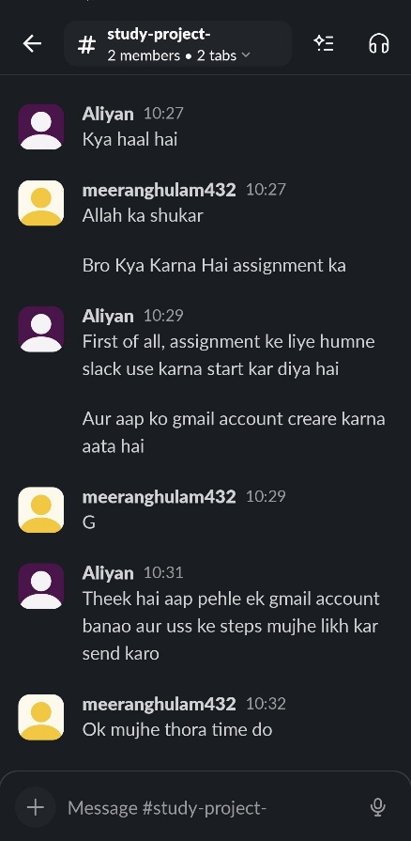
Using Slack
- Setting up slack was quite simple, It just required an account
- The interface felt familiar since I have used a very similar app called discord before
- After getting used to the interface and regular greetings we started working on our assignment

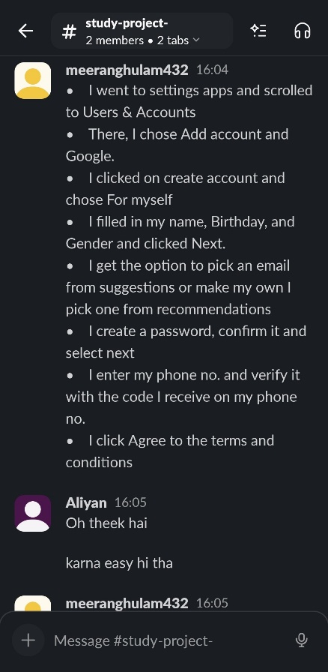

- I really liked how I could use slack on my mobile phone and laptop at the same time
- After completing the part of writing our steps we reviewed our methods carefully
- It was quite a pleasure to use Slack for this assignment
- I am looking forward to using it in upcoming assignments too

